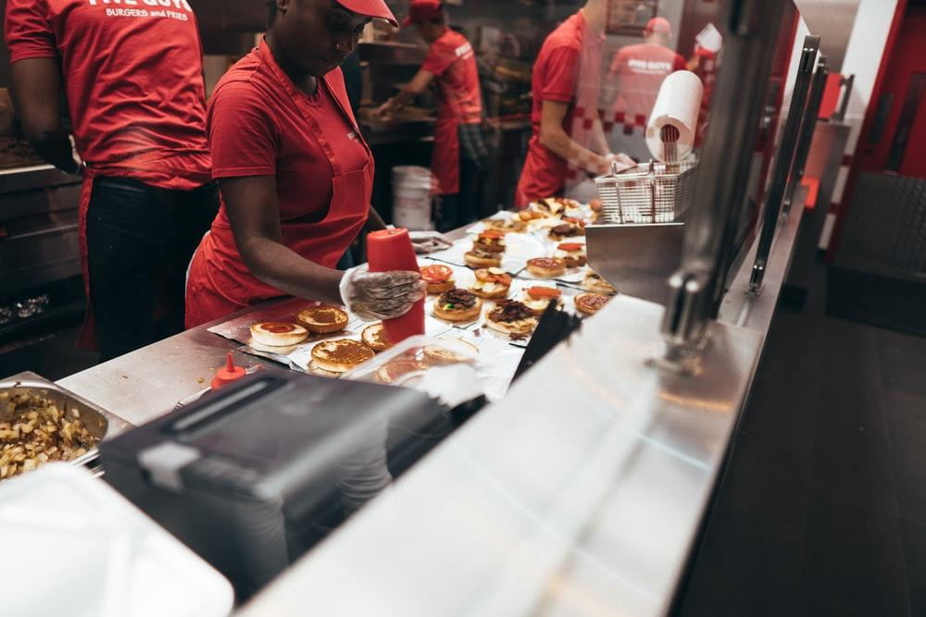
Five Guys, Burger and Lots of Fries
Reviewed by Delaney Whitman

After a nearly two block walk through downtown lansing from the parking garage, me and my entourage arrived at the door of Five Guys, cold and hungry. Along the way we’d questioned whether or not we were going in the right direction and speeded are way along to get out of the cold and dark. I was unfamiliar with the area and had only heard or read about this supposedly good fast food chain restaurant. Unable to take the cold anymore and excited to eat we hurriedly enter the restaurant.
We are greeted only by the oily scent of fried food. I remark how it for some reason smells like mozzarella sticks, my favorite, and I am sadly mistaken when I find out the only side they really offer is fries. The building itself is long and not wide. Instead of the counter being at the front of the room as most are it is way in the back. So we make our way there, passing tables and booths which are sparsely filled with other patrons despite it being dinner time and rush hour. My friends go before me, having eaten here before and not being very choosy about what they get. Overwhelmed by the smell of fried potatoes and griddled burgers and the hurry to try and figure out what I want to be my first meal here I stand back. Leaning my head back to look at their old style menu boards, typical of a fast food restaurant. One is dedicated to the types of burgers they have, another to the toppings you can add on (Free of charge, of course) and another for sizes for fries and drinks. I did not end up reading through the whole menu even though there was not a lot, as I had already decided what I was getting and it was nearing my turn to order.
There was a lot of employees as far as I could see and they were all rather friendly. The kitchen area is right behind the front counters so you can see every step of your food being made. When I ordered the cashier was a rather nice woman who smiled and asked what I would like to have. I made my order having decided on a simple cheeseburger with ketchup and pickles, a regular side of fries and a fountain drink as that was all they offered besides bottled water. I was given a cup and my receipt which on top had my order number, and was sent to wait with my friends.
Playful banter rung out across the restaurant from behind the counter but I paid little mind to it. However, I did remark how loud the music was and how it certainly wasn’t a place to “have a chat”. It was hard for me to hear and I questioned if it was because my ears were cold or just the stuffy atmosphere itself. But we sat ourselves at a high table near the counter and talked while we waited for our food. Other people had made their way and cleaning time began too. A few workers made their way around emptying waste bins and sweeping haphazardly.
I suppose this is the time to talk about the restaurant itself. It had old style tile flooring with a few place down mats here and there, by the kitchen and the entrance. High tables lined the right wall and regular four seater table filled the entrance area. The counter was long and wider, and ran along the back left side of the room. It was rather cramped besides the ceiling which was high. The walls were white and were lined with photographs and framed news clippings of restaurant reviews. Five Guys seemed to be proud as it flaunted reviews pointing out how well their burgers were and how their key selling point was the amount of fries they served, despite being pointed out as rather mediocre. I couldn’t tell you what they all said but I was rather shocked by how projecting they were of their high-lower tier status. Not only that but restaurant review quotes were painted on the walls, mostly near the bathroom entrance. The building itself was classless but there’s not much judgement I can put on it knowing it is a fast food chain.
Aside from that it was decently clean and the tables were not in disarray.
The wait for food was not long, my friend’s food was done first and their number was called out. A few minutes later my number was called and I retrieved my food with something along the lines of
“Enjoy”. I watched as the foil wrapped burger was placed in the bottom of the bag along with a cup of fries and then a metal tray of fries was dumped into the bag to my surprise. I commented on it to my friends who had noted the large amount of fries they had received as well. It seemed a rather sloppy way of doing things but it was an enjoyable spectacle. Somewhere there is a quote about being the fries at the bottom of the bag, unnoticed at first but a thrilling find.
I reached in past the pile of fries and pulled out the foil wrapped burger and the original cup of fries. The fries were nicely done, just as the quotes and reviews had said. Fried in peanut oil to give it a sweet oily taste, seasoned lightly with salt, long peel-on strips of potato. Soft in the middle but not very crisp on the outside, luckily not soggy either making them pleasant and worth taking home the remainder of the fries. A sweet and salty taste, best complemented by the acidic taste of ketchup. The burger was hardly picture perfect,but that’s how good burgers are presented. Simply. Not being much of a burger person I can say that it was one of the best fast food burgers I have had. Each bite was almost perfectly portioned. The sesame seed bun was soft as sweet. An excellent pairing with the smokey meaty taste of burger and the acidity of ketchup and the butter-y vinegar taste of pickles. The burger was a decent size and was well done, which I prefer. It was not overly gritty or smooth, it was a nice texture and a taste that was not greasy as most fast food burgers are. Not many are fans of pickles on their food but I liked it. The pickles Five Guys’ used were laid on thickly but not overbearing, their taste was butter-y sweet and sour. Just the perfect amount of ketchup was added on top of that. There cheese was typical cheddar slices, laid on and melted to the bun. Over all the taste was very well done. But for the price it was at I wouldn’t come back often. You get what you pay for if not more in fries, but the burger itself was nearly seven dollars which was a bit more than what you pay at a place like McDonalds or Wendy’s but the quality makes up for it.
Over all the experience was decent. Nothing high end or fancy, but nothing sloppy or disturbingly greasy. My friends stated they did not plan on coming back but enjoyed their food which wasn’t far off from what I had gotten. Five Guys rates about four stars on the scale of fast food chain restaurants. They are proud of their praise and mediocracy.

